
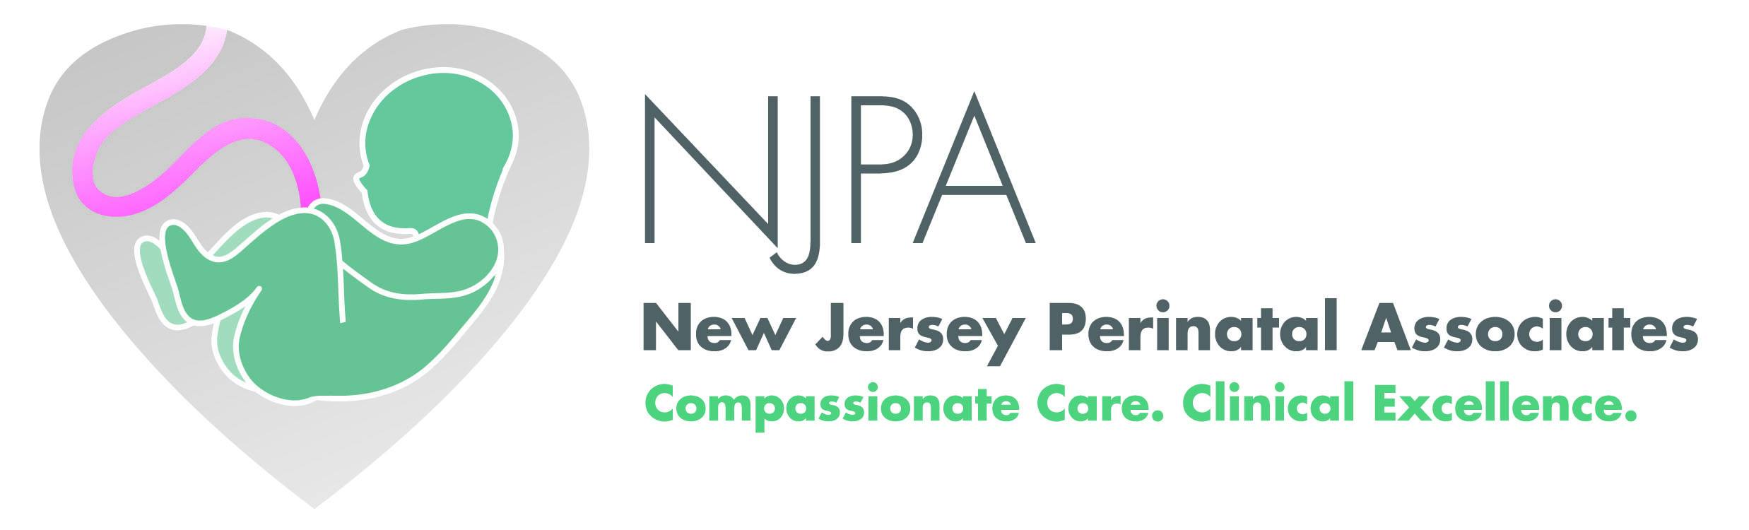

MFM Newsletter
Monochorionic-diamniotic twin gestations are unique in that they are at risk for certain conditions that are not encountered in dichorionic multiple gestations. For example, twin-twin transfusion syndrome is seen in approximately 15% of monochorionic twins and if left untreated, it is associated with extremely poor fetal outcomes and death of either one or both twins. There are also risks to the co-twin survivor with regards to neurological outcomes in the event of a single twin intrauterine fetal demise.

Due to these risks, it is recommended that these pregnancies undergo close fetal surveillance and that these patients be delivered at an earlier gestational age compared to dichorionic twin pregnancies.

There are limited data to establish the optimal timing of delivery for twin pregnancies. ACOG does not provide clear recommendations on this topic, but most experts have proposed earlier delivery recommendations for monochorionic twins based on observed rates of fetal death in the third trimester.

Issue 1
February, 2012
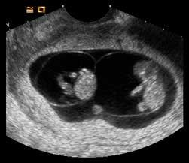

A monochorionic-diamniotic twin gestation as seen in the first trimester
About monochorionic-diamniotic twins…

In this newsletter…
- Management of monochorionic-diamniotic twin gestations

- Information on MaterniT21 testing

- Meet our perinatologist



Please note that New Jersey Perinatal
Associates (NJPA) has developed these best
practice recommendations based on a
review of current literature and expert
opinion. They are not intended to establish
standards or absolute requirements and
these recommendations do not guarantee a
specific outcome. All recommendations and
best practices should be considered in the
context of each patient’s individual
circumstances and clinical evaluation.
References:
- Contemporary management of monochorionic diamniotic twins:outcomes and delivery recommendations revisited. Smith NA, et al. Am J Obstet Gynecol 2010;203:133.e1-6.
- Optimal interval for ultrasound surveillance in monochorionic twin gestation. Thorson HL, et al. Obstet & Gynecol. 2011 Jan;117(1):131-135.
- Monochorionic diamniotic twin pregnancy:timing and duration of sonographic surveillance for detection of twin-twin transfusion syndrome. Carver A, et al. J Ultrasound Med. 2011 Mar;30(3):297-301.

Best practice for the management of
monochorionic-diamniotic twin gestations
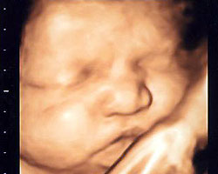
www.njperinatal.com
Continue newsletter text here.
Continue newsletter text here.
Continue newsletter text here.
Continue newsletter text here.
Continue newsletter text here.
Continue newsletter text here.
Continue newsletter text here.
Continue newsletter text here.
Continue newsletter text here.
Continue newsletter text here.
Continue newsletter text here. Continue newsletter text here. Continue newsletter text here. Continue newsletter text here. Continue newsletter text here.

- Chorionicity is best established in the first trimester and patients with multiple gestations should undergo an ultrasound in the first trimester, if possible
- Monitoring for signs of twin-twin transfusion syndrome is recommended beginning at 16 weeks gestation, followed by assessment of amniotic fluid volumes every 2 weeks
- A Level 2 study is recommended between 18-20 weeks gestation
- Serial fetal growth scans at 4 week intervals
- A cervical length assessment is recommended between 22-24 weeks gestation for preterm birth risk prediction
- Weekly antepartum fetal testing beginning at 32 weeks gestation
- Delivery should be considered at 36 weeks gestation
Screening for fetal Down syndrome by DNA sequencing maternal blood with the MaterniT21 test through New Jersey Perinatal Associates (NJPA)
As always, we remain available to answer any questions that you may have. Feel free to contact our genetic counselor, Laura Limone, MS, CGC, at (973) 322-5886.
A recently released commercial test is available to screen your high-risk pregnant population for fetal Down syndrome. The test has been validated in patients with any of the following high risk criteria:
- Advanced maternal age
- Family history of Down syndrome (affected full or half-sibling of current pregnancy)
- Ultrasound abnormality that would cause you to offer CVS/amniocentesis
- Positive Down syndrome screen

The Sequenom clinical validation study showed a Down syndrome detection rate of 99.1% and a false positive rate of 0.2%.

While this is an exciting development that some have predicted may eliminate 98% of invasive diagnostic tests, it comes at this stage with a number of caveats and concerns:
- It is a screening test, NOT a diagnostic test.
- At this time, it IS NOT validated in low risk patients, multiple gestations, Trisomy 13 or Trisomy 18.
- It has not yet been proven to diagnose other chromosomal abnormalities that may have been detected by CVS/amniocentesis/first trimester screening (FTS).
- IT IS NOT A REPLACEMENT FOR FTS AT THIS TIME.

Sequenom does not have well-established payor contracts at this time but current costs could easily range from a minimum of $235 for PPO insured patients to $1900 or more for HMO patients. The retail price is about $2700.

The International Society of Prenatal Diagnosis (ISPD) has made a reasonable statement that stresses and recommends that patients should receive formal genetic counseling prior to undergoing this test.

NJPA concurs with the ISPD statement and will offer the test to patients that meet the inclusion criteria due to the complexity of the screening/testing options. The ideal setting may indeed be referral at 10 weeks gestation that would allow blood draw if indicated and desired at that time with nuchal translucency measurement 2 weeks later. This would allow instant risk assessment in many cases at that time while minimizing the number of invasive prenatal diagnostic tests.

Meet our perinatologist…
Tania Kasdaglis, MD
Dr. Kasdaglis graduated from the Saint George’s University School of Medicine. She completed her residency at Saint Barnabas Medical Center in Livingston, New Jersey before undertaking her fellowship in Maternal Fetal Medicine at the University of Maryland. Dr. Kasdaglis has a strong research interest in the prediction and management of placental dysfunction and the prevention of preterm birth. Dr. Kasdaglis joined NJPA in August of 2011.

www.njperinatal.com
Offices in: Livingston (973) 322-5287, Belleville (973) 450-2589, Warren (908) 769-2577, Teaneck (201) 833-3535, Westfield (908)233-8640



Now Open
in Westfield!

